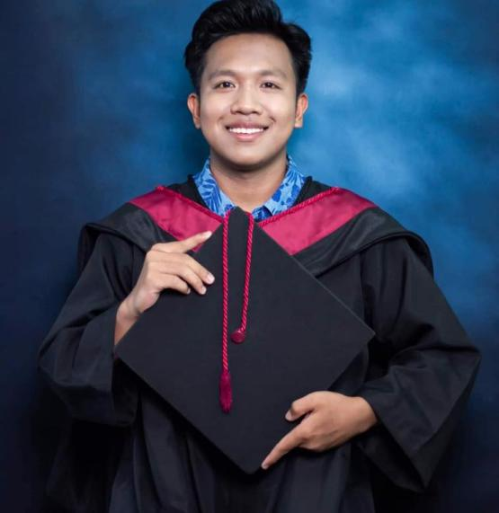

**Address**: Purok #5 Caliguian, Burgos, Isabela 3322

**Contact**: *09318774218*

**Email**: [francissubsilica.fms@gmail.com](mailto:francissubsilica.fms@gmail.com)

**SKILL**

Microsoft Office

Photoshop

Computer Technical

Networking

Encoding

HTML

Java Script

Bootstrap

React.js

Node.js

CSS

TailWind

**EDUCATION**

**Isabela State University-Cauayan Campus**

Bachelor of Science in Computer Science

City of Cauayan, Isabela

(2015-2019)

**Caliguian National High School**

(Caliguian, Burgos, Isabela)

(2011-2015)

**Burgos Central School**

Caliguian, Burgos, Isabela

(2009 – 2011)

**Matapitap Elementary School**

Matapitap, Gerona, Tarlac

(2005 – 2009

**EXPERCIENCE**

**On-the-Job-Training**

(May-June 2018)

College of Computing Studies, Information and Communication Technology

**Hold Down Press Operator**

(Jan 2021 – Feb 2022)

Universal Leaf Philippines Inc.

**Virtual Assistant**

(July 2023)

**OBJECTIVES**

* Self-independent, reliable, and friendly individual who works hard to achieve personal goals
* Quick to adapt and well-organized, I am interested in staying abreast of the latest developments and continuously learning
* Versatile professional excelling in teamwork and individual performance, dedicated to achieving future goals through a strong work ethic.

_________

**FRANCIS MAR B. SUBSILICA**